BDBP-106 LAB 1

1)
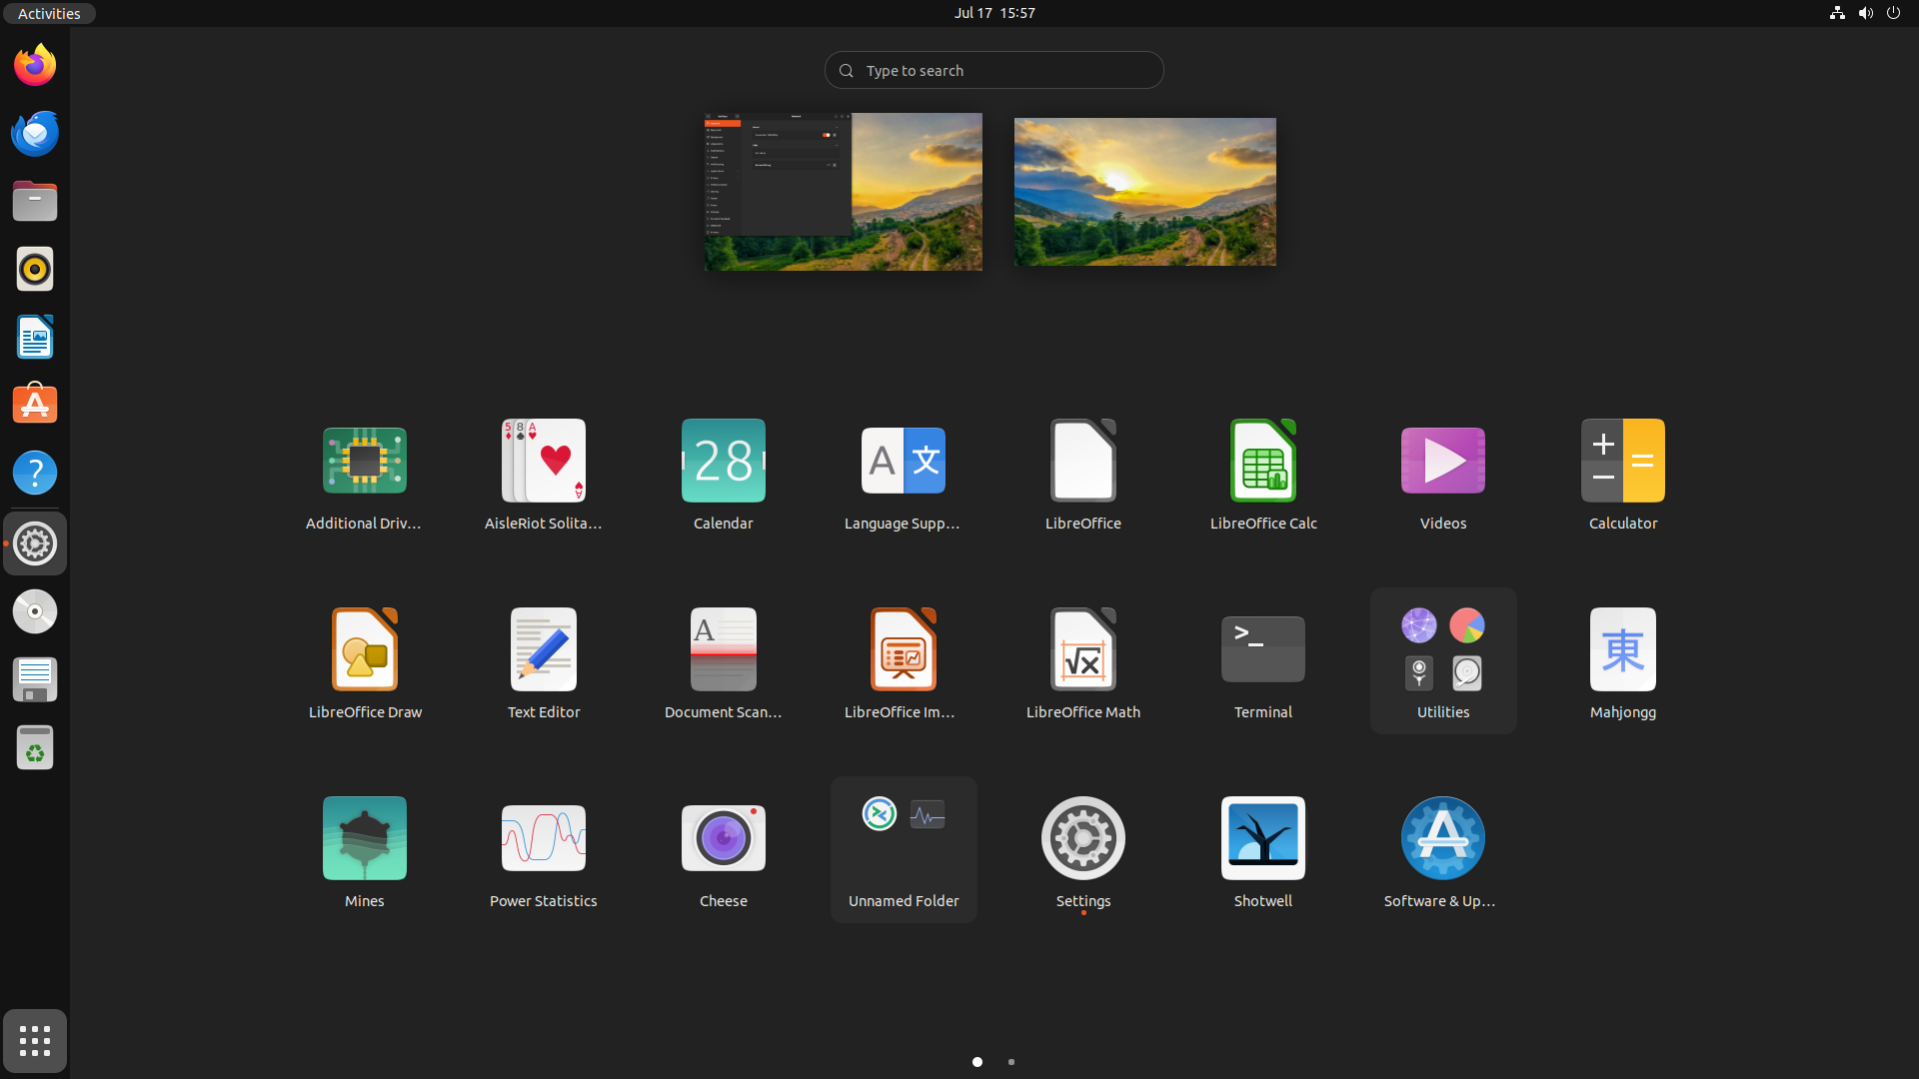
(i) Start Menu: It consists of different softwares, start menu, search bar and desktop view.

(ii) Taskbar/favourites bar, date and time, network information, login/logout, folder button, settings button and its features, screenshots, user login area

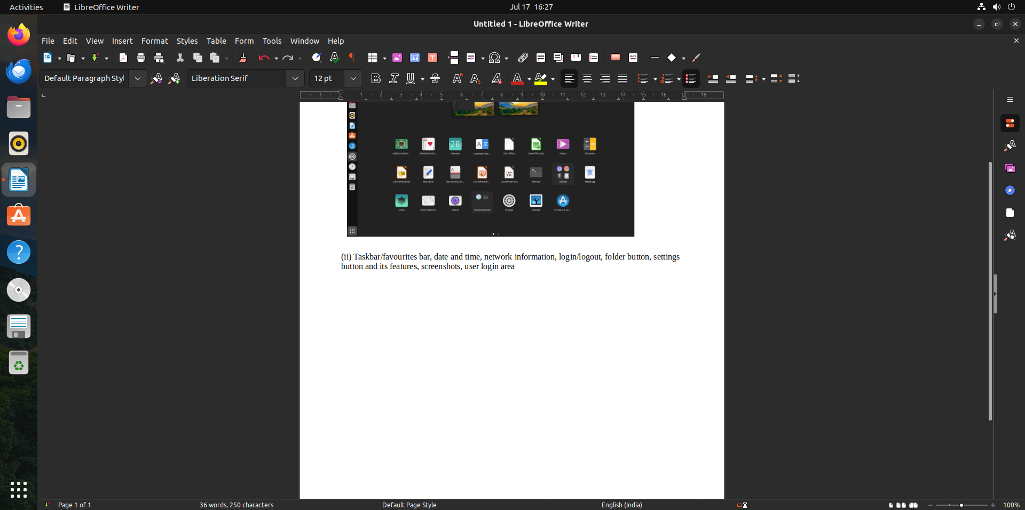

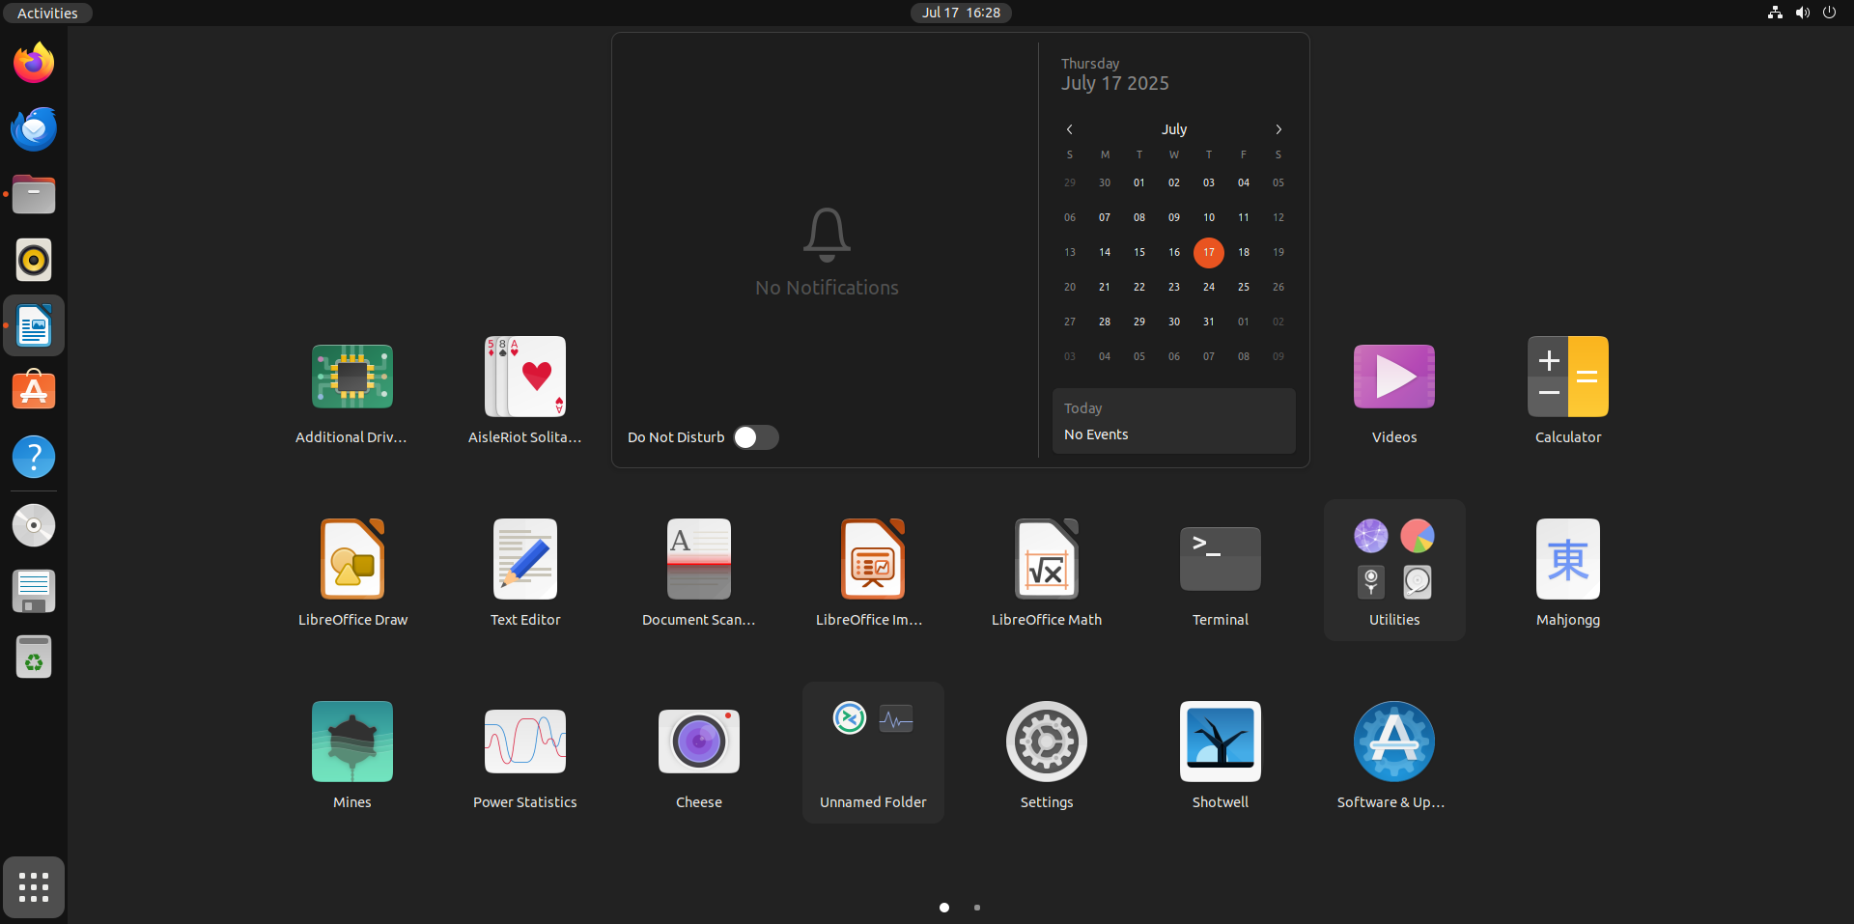

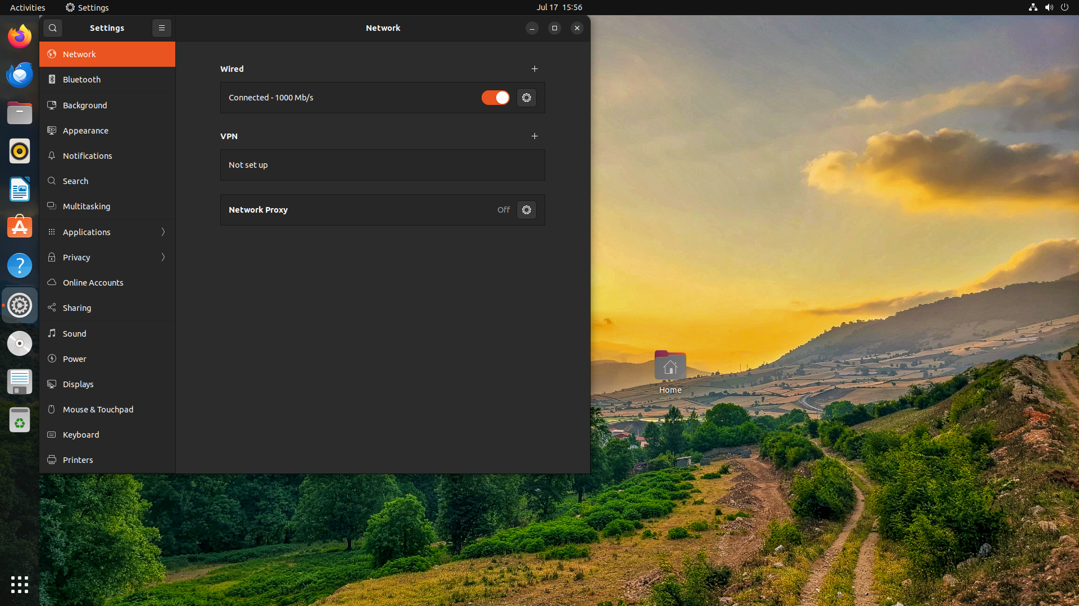

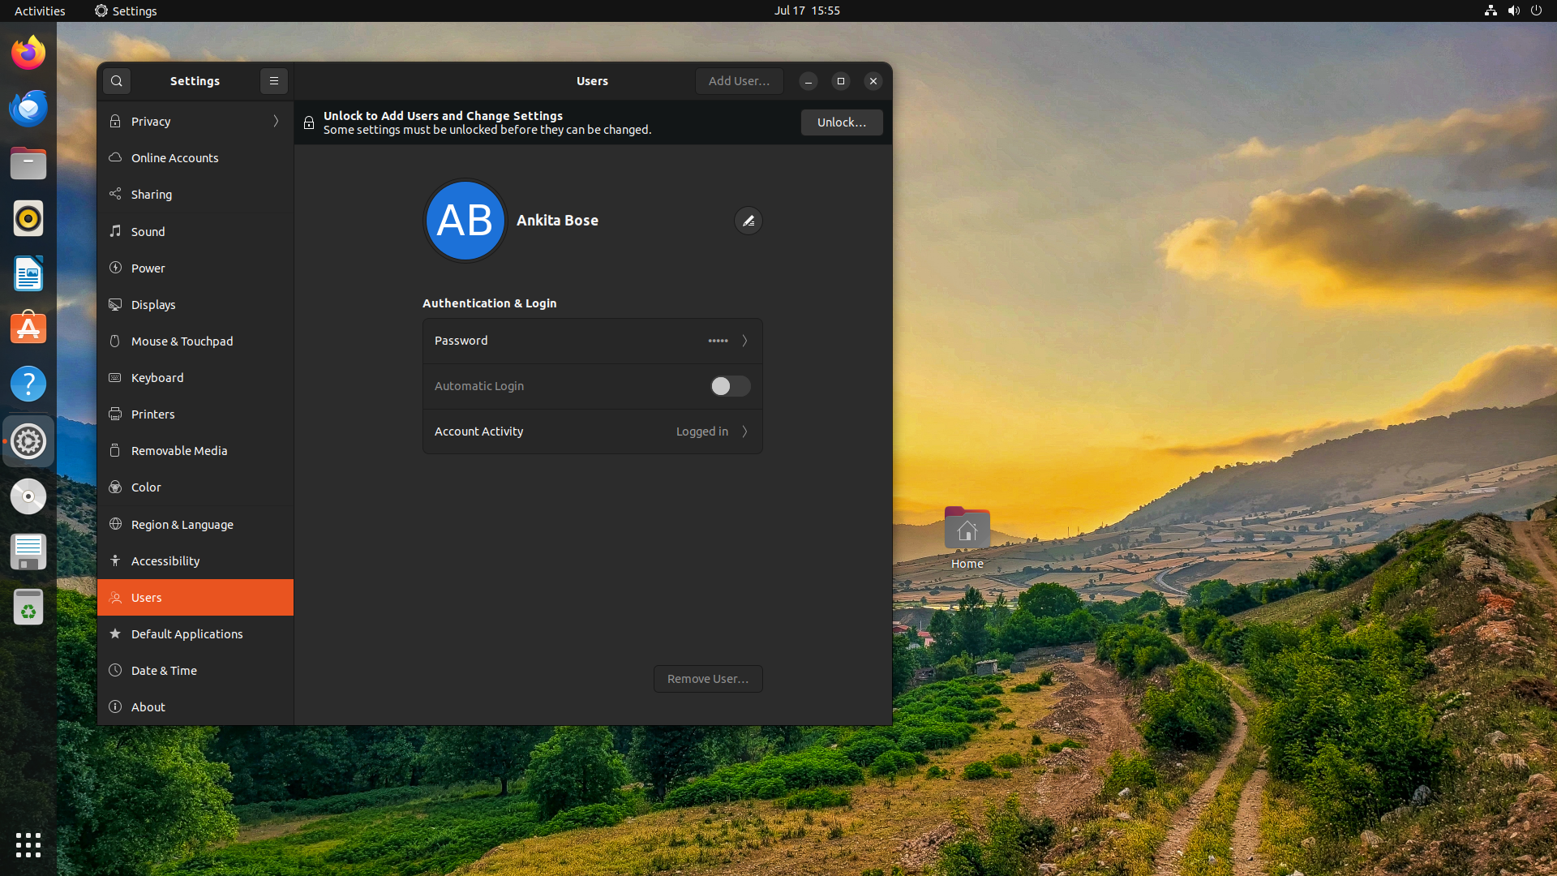
iii) Color change and backgound change
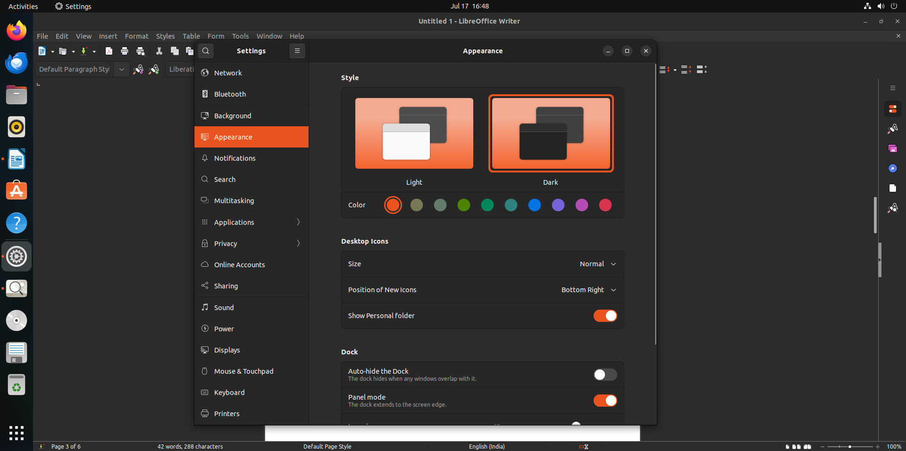

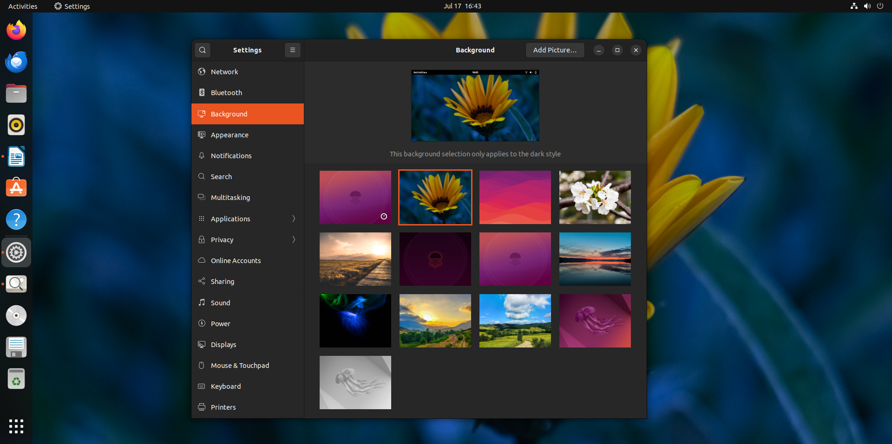

iv) List of information in the network settings

In the network settings tab of a linux system, you can view and configure network-related information. It typically shows-
- wifi
- IP address
- MAC address
- Gateway
- DNS Servers
- network interface name
- connection speed
- option edit/configure
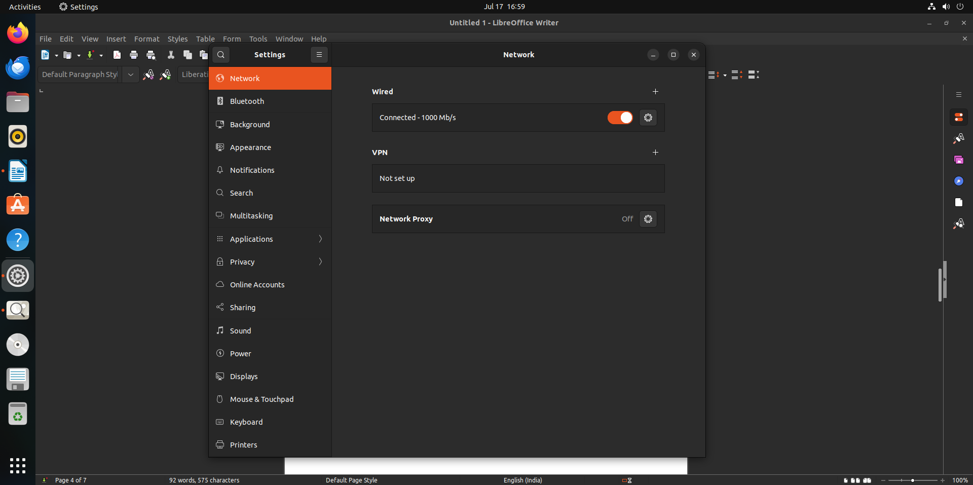

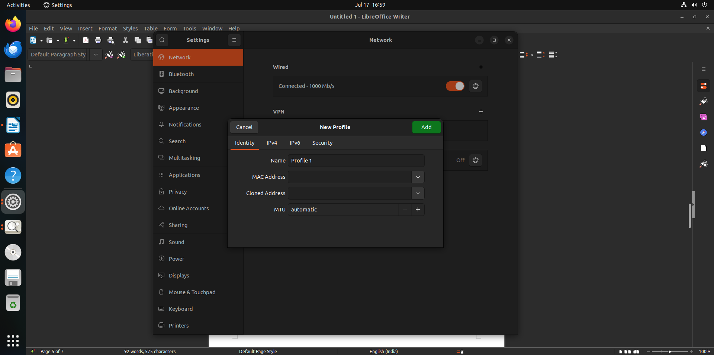

v) List of pre-installed software
- additional drivers : tool to manage drivers
- calender
-language support
-libre office
-libre office calculator
- videos- media player
- calculator
-utilities
- mahjongg - game
- terminal- command line interface
-libre office
- libre office impress- presentations and slideshows
-doc scanner
- cheese- webcam
- settings
-shotwell- gallery
-power statistics- to view power usage
-text editor
-libre office draw
-mines – game
-software updater

vi)
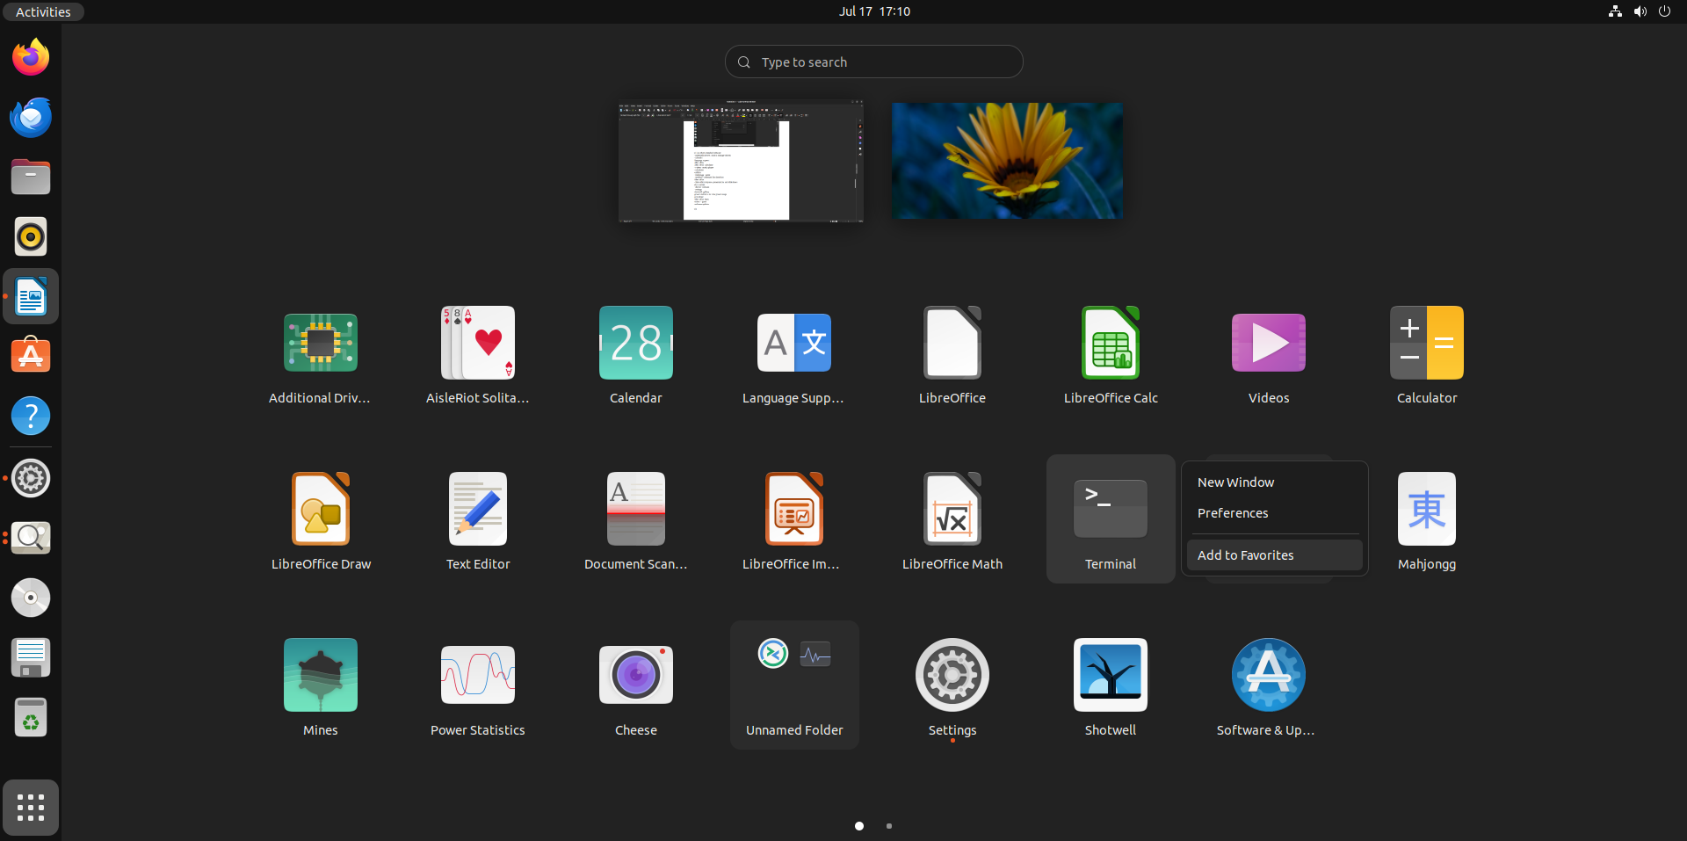
3)
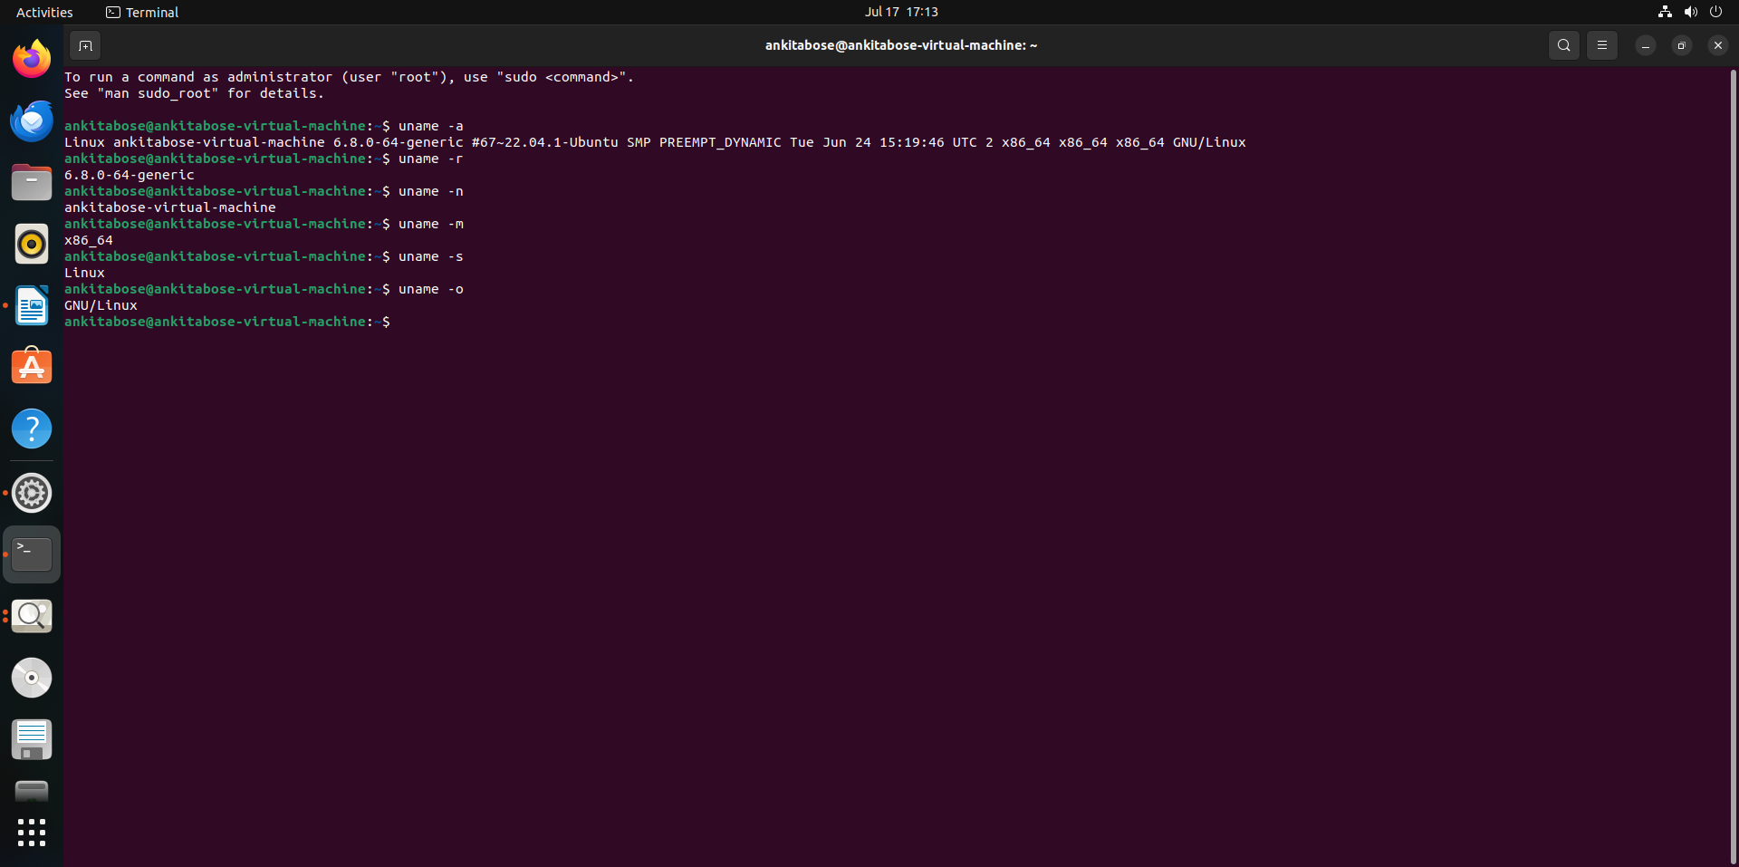

(i)
Linux
<ankitabose-virtual-machine>
<6.8.0-64-generic #67~22.04.1-Ubuntu >
<SMP PREEMPT_DYNAMIC >
<Tue Jun 24 15:19:46 >
<UTC 2>
<x86_64>
<x86_64>
<x86_64>
<GNU/Linux>
(ii)
ankitabose@ankitabose-virtual-machine:~$ uname -r
6.8.0-64-generic
ankitabose@ankitabose-virtual-machine:~$ uname -n
ankitabose-virtual-machine
ankitabose@ankitabose-virtual-machine:~$ uname -m
x86_64
ankitabose@ankitabose-virtual-machine:~$ uname -s
Linux
ankitabose@ankitabose-virtual-machine:~$ uname -o
GNU/Linux

